The ASP.NET Web API is an extensible framework for building HTTP based services that can be accessed in different applications on different platforms such as web, windows, mobile etc.

It works more or less the same way as ASP.NET MVC web application except that it sends data as a response instead of html view.

It is like a webservice or WCF service but the exception is that it only supports HTTP protocol.

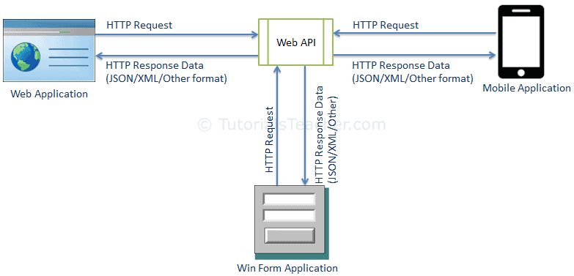

REST : **REPRESENTATIONAL STATE TRANSFER PROTOCOL**

**HTTP VERBS : HTTP GET : FOR READING, HTTP POST :FOR ADDING , HTTP PUT : FOR UPDATING, HTTP DELETE : FOR DELETING**

**CRUD OPERATIONS**

ASP.NET Web API Characteristics

1. ASP.NET Web API is an ideal platform for building RESTful services.
2. ASP.NET Web API is built on top of ASP.NET and supports ASP.NET request/response pipeline
3. ASP.NET Web API maps HTTP verbs to method names.
4. ASP.NET Web API supports different formats of response data. Built-in support for JSON, XML, BSON format.
5. ASP.NET Web API can be hosted in IIS, Self-hosted or other web server that supports .NET 4.0+.
6. ASP.NET Web API framework includes new HttpClient to communicate with Web API server. HttpClient can be used in ASP.MVC server side, Windows Form application, Console application or other apps.

ASP.NET Web API Versions

| Web API Version | Supported .NET Framework | Coincides with | Supported in |
| --- | --- | --- | --- |
| Web API 1.0 | .NET Framework 4.0 | ASP.NET MVC 4 | VS 2010 |
| Web API 2 - Current | .NET Framework 4.5 | ASP.NET MVC 5 | VS 2012, 2013 |

When to choose ASP.NET Web API?

* Choose Web API if you are using .NET framework 4.0 or above.
* Choose Web API if you want to build a service that supports only HTTP protocol.
* Choose Web API to build RESTful HTTP based services.
* Choose Web API if you are familiar with ASP.NET MVC.